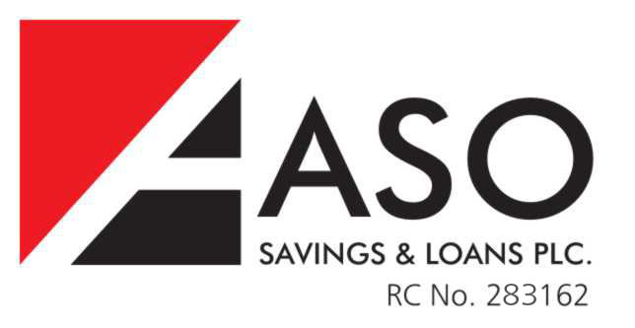

NAME
ADDRESS
CITY, STATE

Dear (Name),

INVITATION TO PARTICIPATE in the 2nd ASO National Housing Exhibition & Conference

We are pleased to invite you to participate in the 2nd ASO National Housing Exhibition & Conference scheduled to hold from March 15 – 17, 2012
Here, participants can showcase the very latest products and services from their respective industries. You will have the unique opportunity to present your products and services (as it relates to the Housing market) to the general public from all over Nigeria - all under one roof. You can also take advantage of a range of advertising and sponsorship options, which will enable you to reach your targeted groups via the printed brochure and other advertising opportunities.
The schedule is as follows:

March 15 – 17
Venue: International Conference Center, Abuja
Time: 8:a.m – 5:30pm Daily

Participants include (but are not limited to):

Estate Developers
Architectural firms
Interior decorators
Appliance Resellers
Contractors
Mortgage Providers
Construction firms
Building Materials firms
State Governments etc

Etc

Sponsorship:
Sponsors are encouraged to enroll in one of the three sponsorship levels of the Exhibition and Conference for access to the different levels of exposition possibilities offered in connection with these sponsorships:

Diamond Sponsor
A Diamond Sponsor is one who contributes N1.5 million and the benefits at this level are:
- Acknowledged with logo as a Diamond Sponsor in the brochure and agenda
- Two full color page advert pages in brochure/event materials
- Free double booth at the Exhibition (3m x 6m) in premium location (at entrance of venue)
- Advertorial in a national newspaper
- Logo placement on website
- Scheduled VIP tour of exhibition
- 4 free invitation to commissioning of event
- 6 event pack ( includes entrance pass, brochure and free gifts)
- Brand awareness in event and all event materials

Gold Sponsor
A Gold Sponsor is one who contributes N 750,000 and the benefits at this level are:
- Acknowledged with logo as a Gold Sponsor in the brochure and agenda
- One full color page advert pages in brochure/event materials
- Free Single booth at the Exhibition (3m x 3m) in prime location
- Mention in a national newspaper
- Logo placement on website
- 2 free invitation to commissioning of event
- 4 event pack( includes entrance pass, brochure and free gifts)
- Brand awareness in event and all event materials

Silver Sponsor
A Silver Sponsor is one who contributes N300,000 and the benefits at this level are:
- Acknowledged with logo as a Silver Sponsor in the brochure and agenda
- Logo placement on website
- 1 free invitation to commissioning of event
- 2 event pack ( includes entrance pass, brochure and free gifts)
- Brand awareness in event and all event materials

Advert Placement
Advert spaces in the brochure will be allocated based on availability, on a first come, first served basis.

POSITION | RATE
INSIDE FRONT COVER | N150,000.00
INSIDE BACK COVER | N150,000.00
OUTSIDE BACK COVER | N180,000.00
CENTER SPREAD | N200,000.00
INSIDE PAGE | N100,000.00

PLEASE NOTE: SOFT COPIES (on flash or CD – preferably JPEG or Corel) should be delivered two weeks before the event date.

REGISTRATION

- Please go online to www.asoplc.com/exhibition
- Select Registration
- Provide your company/business information
- Make the following sections:
  - Booth (please note this will be reserved, pending receipt of your payments)
  - Sponsorship (optional)
  - Advert (optional)
- You will receive a confirmation number after you submit your form online
- Go to a nearby ASO branch and make payments within 24 hours (using the confirmation number). Please note, we will no longer reserve your booth selection after 24 hours if payments have not been made, and you will be required to re-register again
- We will send you a confirmation within 48 hours of receiving payments with the following:
  - Booth number
  - Advert (if selected)
  - Sponsorship (if selected)

We thank you and look forward to your presence and participation. Please contact the undersigned for any further enquiries:

Eziokwu Nwafor-Orizu Princewill Amadi

