www.asoplc.com
ASO INTERNET BANKING

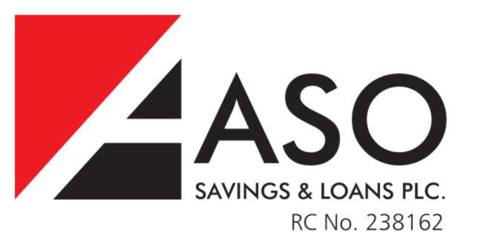
ACCOUNT OPENING APPLICATION FORM
D
D
M
M

Y
Y
Y
Y
Date:
Account Name: ____________________________________________________

Account Numb:
Email Address: ____________________________________ Same as T24? YES NO
Tele Number : ____________________________________
Mother’s Maiden Name: _____________________________
Default internet banking information (telephone, security question & email) must be same as in your information with the bank. Please ask our customer service officer if you choose to update your records.
INTERNET BANKING TOKEN
To ensure the security of my online transactions, ASO Internet Banking uses a hardware token for password authentication.
Pick Up Option
Self Courier (only available outside Nigeria) Proxy
Please complete our 3rd party collection indemnity form if you have chosen either the courier or proxy delivery methods
Courier delivery will only be allowed for delivery outside Nigeria
Delivery address: _______________________________________________________
_____________________________________________________________________
Your chosen proxy comes along with a signed letter authorizing him/her to collect your token. Proxy Identification: Kindly indicate here the ID your proxy will present upon arrival at the bank
Your chosen proxy must provide the identification stated above.
I, __________________________ hereby authorize ASO Savings & Loans Plc to debit my account number ______________________ with the cost of the internet banking token. I confirm that I have read and understand the terms and conditions of this service.

_____________________________ __________________________
Authorized Signature Authorized Signature
FOR OFFICE USE ONLY
Processors: (Name, Signature & Date)
CSO : _______________________________ HOP: ______________________________

TOKEN STATUS: ________________________________________________________________

